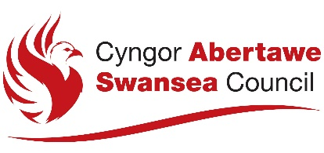

Form B for joint applications by more than one individual or company

NOTICE OF APPLICATION FOR A PREMISES LICENCE UNDER THE GAMBLING ACT 2005

Notice is hereby given that

[Give the full name of the applicant(s)]

of the following address:

is / are applying for a premises licence under section 159 of the Gambling Act 2005. [Insert kind of premises licence being applied for]

The application relates to the following premises:

[Give the trading name to be used at the premises, and the address of the premises (or, if none, give a description of the premises and their location).]

The application relates to the following premises:

The Licensing Division
Housing and Public Protection
Directorate of Place
City and County of Swansea
Civic Centre
Oystermouth Road
Swansea
SA1 3SN

www.swansea.gov.uk

Information about the application is available from the licensing authority, including the arrangements for viewing the details of the application.

Any of the following persons may make representations in writing to the licensing authority about the application:
- A person who lives sufficiently close to the premises to be likely to be affected by the authorised activities.
- A person who has business interests that might be affected by the authorised activities.
- A person who represents someone in any of the above two categories.

Any representations must be made by the following date:

It is an offence under section 342 of the Gambling Act 2005 if a person, without reasonable excuse, gives to a licensing authority for a purpose connected with that Act information which is false or misleading.

