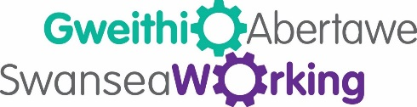

Your Knowledge, Skills, and Abilities Guide

Having built new knowledge, skills and abilities, you may still need help to know how to utilise them to progress in your career.

Knowledge – the subjects, topics, and items of information that an employee should know.

Skills – technical or manual, which are usually learned or acquired through training.

Abilities – applying several knowledge and skills simultaneously in order to complete a task.

Swansea Working can help you drive your knowledge, skills and abilities forward.

You will have all the right parts. Think of a car engine. Your mind is the engine and you now have all the knowledge, skills and abilities that you need to make your engine run.
The key in the ignition is to think positively. When the key turns, the engine cycle begins. Air and fuel are drawn into the cylinders and then the spark plugs fire. This begins combustion. Drive, don’t reverse!

If you’ve taken a course recently, if you’ve built confidence in other areas, if you’ve taken advice on board, reach for your goal at that very moment, competently displaying your skills. Don’t be afraid of your gifts or let them go to waste.

Follow the guide below to help you along the way:

- List the strengths you have gained and the weaknesses you have overcome

- Apply your new skills in writing (CV, cover letters and job applications), face to face (in meetings and at interviews) and online (media platforms and applying for jobs online). Be proud of your training and knowledge. Don’t be scared to use it and show it off.

- Become a specialist in taking action. Nerves and excuses may be too frequently thrown about to avoid action. When there are opportunities for development, focus on your own progress.

- Share your knowledge and support others while you progress higher. Take time to encourage your colleagues to seize their own opportunities. You might not be surprised by how much you know but others will. People will appreciate you sharing and supporting them along the way.

- Commit to continual professional development. Seek out new ways to improve your chances of developing in your career.

